Задача "сообщение про ssh ключ на хосте с FreeIPA" (https://forge.tcsbank.ru/case/6312569/info).
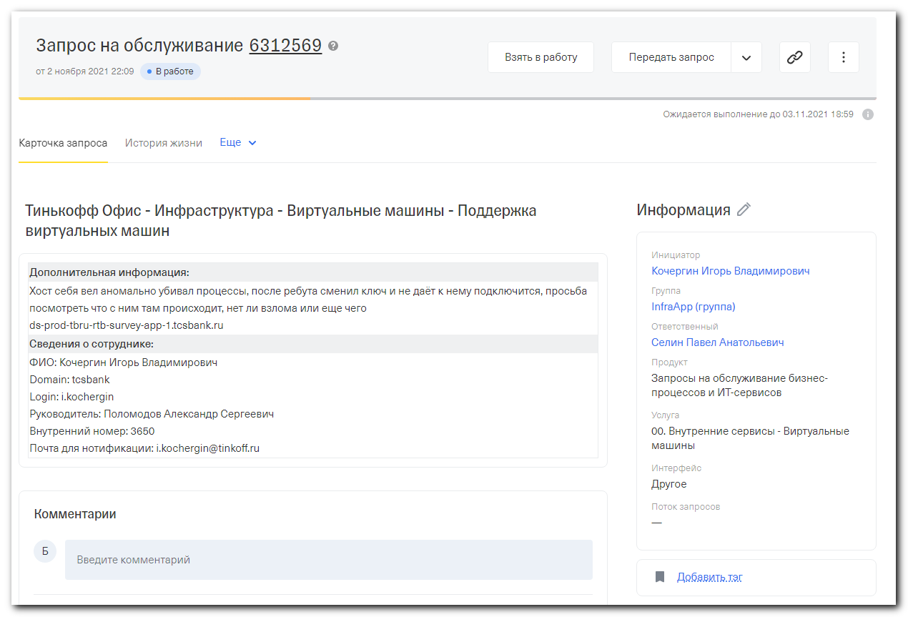

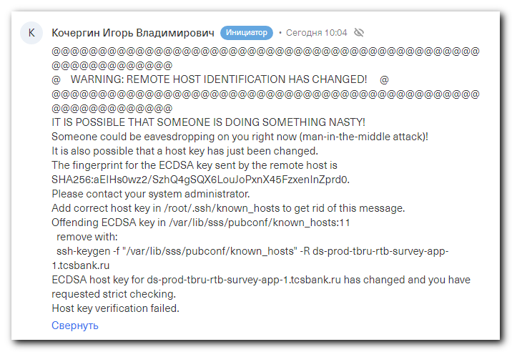

Кочергин Игорь Владимирович
Инициатор
• Сегодня 10:04
@@@@@@@@@@@@@@@@@@@@@@@@@@@@@@@@@@@@@@@@@@@@@@@@@@@@@@@@@@@
@ WARNING: REMOTE HOST IDENTIFICATION HAS CHANGED! @
@@@@@@@@@@@@@@@@@@@@@@@@@@@@@@@@@@@@@@@@@@@@@@@@@@@@@@@@@@@
IT IS POSSIBLE THAT SOMEONE IS DOING SOMETHING NASTY!
Someone could be eavesdropping on you right now (man-in-the-middle attack)!
It is also possible that a host key has just been changed.
The fingerprint for the ECDSA key sent by the remote host is
SHA256:aEIHs0wz2/SzhQ4gSQX6LouJoPxnX45FzxenInZprd0.
Please contact your system administrator.
Add correct host key in /root/.ssh/known_hosts to get rid of this message.
Offending ECDSA key in /var/lib/sss/pubconf/known_hosts:11
remove with:
ssh-keygen -f "/var/lib/sss/pubconf/known_hosts" -R ds-prod-tbru-rtb-survey-app-1.tcsbank.ru
ECDSA host key for ds-prod-tbru-rtb-survey-app-1.tcsbank.ru has changed and you have requested strict checking.
Host key verification failed.

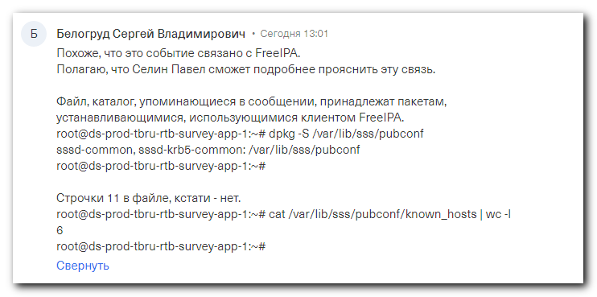
Белогруд Сергей Владимирович
• Сегодня 13:01
Похоже, что это событие связано с FreeIPA.
Полагаю, что Селин Павел сможет подробнее прояснить эту связь.

Файл, каталог, упоминающиеся в сообщении, принадлежат пакетам, устанавливающимися, использующимися клиентом FreeIPA.
root@ds-prod-tbru-rtb-survey-app-1:~# dpkg -S /var/lib/sss/pubconf
sssd-common, sssd-krb5-common: /var/lib/sss/pubconf
root@ds-prod-tbru-rtb-survey-app-1:~#

Строчки 11 в файле, кстати - нет.
root@ds-prod-tbru-rtb-survey-app-1:~# cat /var/lib/sss/pubconf/known_hosts | wc -l
6
root@ds-prod-tbru-rtb-survey-app-1:~#

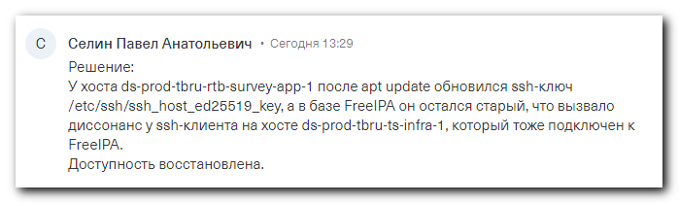
Селин Павел Анатольевич
• Сегодня 13:29
Решение:
У хоста ds-prod-tbru-rtb-survey-app-1 после apt update обновился ssh-ключ /etc/ssh/ssh_host_ed25519_key, а в базе FreeIPA он остался старый, что вызвало диссонанс у ssh-клиента на хосте ds-prod-tbru-ts-infra-1, который тоже подключен к FreeIPA.
Доступность восстановлена.

# Multiple search pattern found "sssd" in freeipa role.
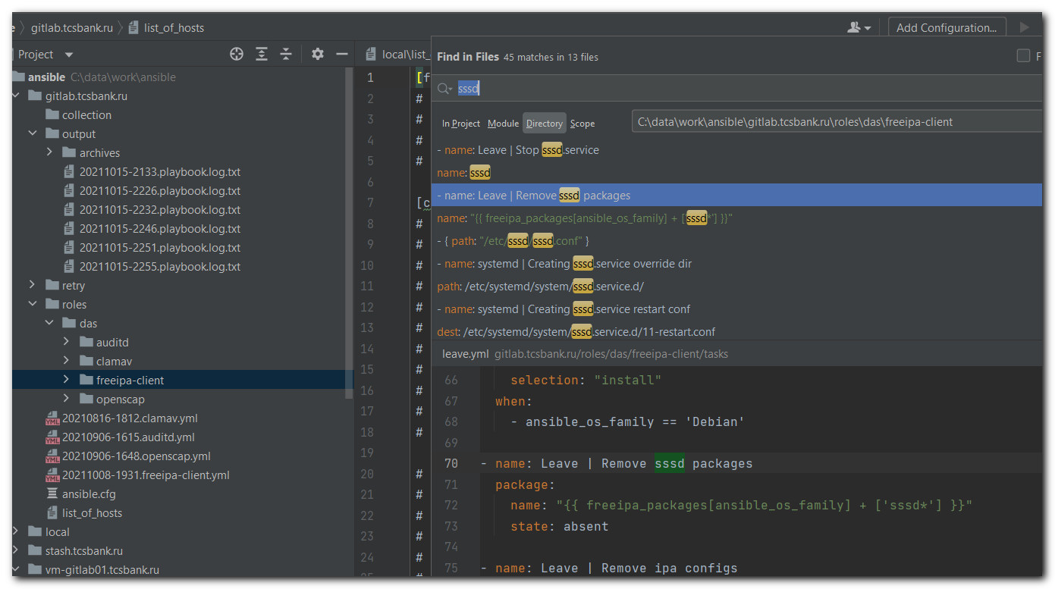

root@ds-prod-tbru-rtb-survey-app-1:~# cat /var/lib/sss/pubconf/known_hosts | wc -l
6
root@ds-prod-tbru-rtb-survey-app-1:~#

root@ds-prod-tbru-rtb-survey-app-1:~# egrep -ie "ds-prod-tbru-rtb-survey-app-1" /var/lib/sss/pubconf/known_hosts

root@ds-prod-tbru-rtb-survey-app-1:~# dpkg -S /var/lib/sss/pubconf/known_hosts
dpkg-query: no path found matching pattern /var/lib/sss/pubconf/known_hosts
root@ds-prod-tbru-rtb-survey-app-1:~# dpkg -S /var/lib/sss/pubconf
sssd-common, sssd-krb5-common: /var/lib/sss/pubconf
root@ds-prod-tbru-rtb-survey-app-1:~#

root@ds-prod-tbru-rtb-survey-app-1:~# dpkg -s sssd-common
Package: sssd-common
Status: install ok installed
Priority: extra
Section: utils
Installed-Size: 4160
Maintainer: Ubuntu Developers <ubuntu-devel-discuss@lists.ubuntu.com>
Architecture: amd64
Source: sssd
Version: 1.16.1-1ubuntu1.8
Replaces: sssd (<< 1.10.0~beta2-1), sssd-krb5-common (<< 1.13.1-1)
Depends: python3, python3-sss, libc-ares2 (>= 1.7.0), libc6 (>= 2.14), libcurl3-gnutls (>= 7.16.3), libdbus-1-3 (>= 1.9.14), libdhash1 (>= 0.4.0), libglib2.0-0 (>= 2.12.0), libhttp-parser2.7.1 (>= 2.1), libini-config5 (>= 0.6.0), libjansson4 (>= 2.0.1), libkeyutils1 (>= 1.4), libkrb5-3 (>= 1.11+dfsg), libldap-2.4-2 (>= 2.4.15), libldb1 (>= 0.9.21), libnfsidmap2, libnl-3-200 (>= 3.2.7), libnl-route-3-200 (>= 3.2.7), libnspr4 (>= 2:4.9-2~), libnss3 (>= 2:3.
13.4-2~), libpam0g (>= 0.99.7.1), libpcre3, libpopt0 (>= 1.14), libref-array1 (>= 0.4.0), libselinux1 (>= 1.32), libsemanage1 (>= 2.0.3), libsss-certmap0, libsss-idmap0, libsss-nss-idmap0, libsystemd0, libtalloc2 (>= 2.0.4~git20101213), libtdb1 (>= 1.2.7+git20101214), libtevent0 (>= 0.9.13), adduser
Recommends: bind9-host, libnss-sss, libpam-sss, libsss-sudo
Suggests: apparmor, sssd-tools
Breaks: sssd (<< 1.10.0~beta2-1), sssd-krb5-common (<< 1.13.1-1)
Conffiles:
/etc/apparmor.d/usr.sbin.sssd 1eba66048b636e0138e8e759c56143c7
/etc/default/sssd 0f787bf54f56d1ce12c3bb6d64d38cbb
/etc/init.d/sssd b67df2d934e05f6c38e6eca6ab0ee72f
/etc/logrotate.d/sssd-common 7c10a0f2db89ef685db568b221552663
/etc/pam.d/sssd-shadowutils b6a400894f4644feb716aa6523b9d54f
Description: System Security Services Daemon -- common files
Provides a set of daemons to manage access to remote directories and
authentication mechanisms. It provides an NSS and PAM interface toward
the system and a pluggable backend system to connect to multiple different
account sources. It is also the basis to provide client auditing and policy
services for projects like FreeIPA.
.
This package provides the daemon and other common files needed by the
authentication back ends.
Homepage: https://pagure.io/SSSD/sssd/
Original-Maintainer: Debian SSSD Team <pkg-sssd-devel@lists.alioth.debian.org>
You have new mail in /var/mail/root
root@ds-prod-tbru-rtb-survey-app-1:~#

